UNIT 5
WWW
The Internet grew out of the Advanced Research Projects Agency's Wide Area Network (then called ARPANET) established by the US Department Of Defense in 1960s for collaboration in military research among business and government laboratories.
The term "World Wide Web" (WWW) refers to the collection of public websites connected to the internet worldwide, together with client devices such as computers and cell phones that access its content. For many years it has become known simply as "the web."
Origination and Early Development of the World Wide Web
Researcher Tim Berners-Lee led the development of the World Wide Web in the late 1980s and early 1990s. He helped build prototypes of the original core web technologies and coined the term "WWW." Websites and web browsing exploded in popularity during the mid-1990s and continue to be a key usage of the internet today.
Web browser
A web browser is a software program that allows a user to locate, access, and display web pages. In common usage, a web browser is usually shortened to "browser." Browsers are used primarily for displaying and accessing websites on the internet, as well as other content created using languages such as Hypertext Markup Language (HTML) and Extensible Markup Language (XML).
Browsers translate web pages and websites delivered using Hypertext Transfer Protocol (HTTP) into human-readable content. They also have the ability to display other protocols and prefixes, such as secure HTTP (HTTPS), File Transfer Protocol (FTP), email handling, and files . In addition, most browsers also support external plug-ins required to display active content, such as in-page video,
A variety of web browsers are available with different features, and are designed to run on different operating systems. Common browsers include Internet Explorer from Microsoft, Firefox from Mozilla, Google Chrome, Safari from Apple, and Opera. All major browsers have mobile versions that are lightweight versions for accessing the web on mobile devices.
Web browsers date back to the late 1980s when an English scientist, Tim Berners-Lee, first developed the ideas that led to the World Wide Web (WWW). This consisted of a series of pages created using the HTML language and joined or linked together with pointers called hyperlinks. Following this was the need for a program that could access and display the HTML pages correctly – the browser.
Internet
A means of connecting a computer to any other computer anywhere in the world via dedicated routers and servers. When two computers are connected over the Internet, they can send and receive all kinds of information such as text, graphics, voice, video, and computer programs.
No one owns Internet, although several organizations the world over collaborate in its functioning and development. The high-speed, fiber-optic cables (called backbones) through which the bulk of the Internet data travels are owned by telephone companies in their respective countries.

Basic Services of Internet / What you can do on the internet
- look up information
- grocery shopping
- book holidays
- keep in touch
- follow your hobbies
- search for a job
- research your family history
- save money
- find ways to get healthy
- buy and listen to music
- watch videos and the news
- banking and pay bills

Difference between website and portal.

A website is the group of web pages which are placed in a location on the internet and accessed through a web address. Content on a website is globally visible, publically used, remains same for the different individuals. Users need not to login for accessing the website. The user can perform any specific task, and the website supports it.
A website could be industry-specific, product specific or services specific etc.; these websites are intended to educate their site visitors about their industry, products or services information. There is no use of a personalized database.
Definition of Portal
A web portal is a typical knowledge management system that delivers the facility for organisation or companies to build, share, interchange and reuse knowledge. It is the private location on the internet retrieved through a unique URL (web address), and probably login id and password. Web portal content is login protected and user specific and its interface could be public and private.
Contents in a web portal are dynamic and changed frequently. The visibility of one content changes from person to person which means a content could be unique to a user based on group member settings. Contents are collected from the different and diverse sources.
Key Differences Between Website and Portal
- A website is a set of interlinked web pages hosted from the same domain, which can be accessed through a web address. As against a portal is a custom-made website which involves information from a broad class of sources in a persistent manner.
- A portal is usually user-centric whereas a website is owned by an organization or company etc.
- There is no intercommunication between the website and the user. On the contrary, a user can interact with the portal.
- A website is not a primary knowledge domain whereas portal is the passage to knowledge management system.
- The information is regularly updated in case of a portal. In contrast, the information sources in a website are rarely updated.

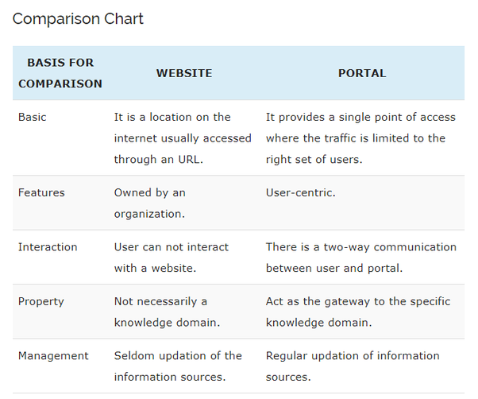
Communication types – Simplex, Half Duplex, Full Duplex
Transmission mode means transferring of data between two devices. It is also known as communication mode.
There are three types of transmission mode:-
• Simplex Mode
• Half-Duplex Mode
• Full-Duplex Mode
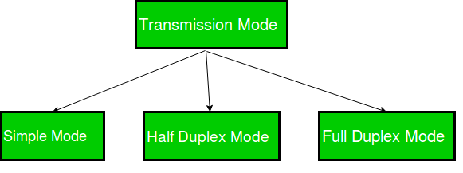
Simplex Mode
In Simplex mode, the communication is unidirectional, as on a one-way street. Only one of the two devices on a link can transmit, the other can only receive. The simplex mode can use the entire capacity of the channel to send data in one direction.
Example: Keyboard and traditional monitors. The keyboard can only introduce input, the monitor can only give the output.



Half-Duplex Mode
In half-duplex mode, each station can both transmit and receive, but not at the same time. When one device is sending, the other can only receive, and vice versa. The half-duplex mode is used in cases where there is no need for communication in both direction at the same time. The entire capacity of the channel can be utilized for each direction.
Example: Walkie- talkie in which message is sent one at a time and messages are sent in both the directions.
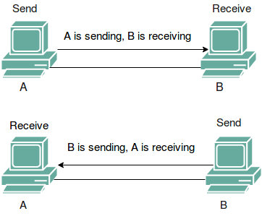
Full-Duplex Mode
In full-duplex mode, both stations can transmit and receive simultaneously. In full_duplex mode, signals going in one direction share the capacity of the link with signals going in other direction, this sharing can occur in two ways:
- Either the link must contain two physically separate transmission paths, one for sending and other for receiving.
Or
- the capacity is divided between signals travelling in both directions.

Full-duplex mode is used when communication in both direction is required all the time. The capacity of the channel, however must be divided between the two directions.
Example: Telephone Network in which there is communication between two persons by a telephone line, through which both can talk and listen at the same time.
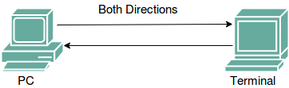

Communication Channels – Twisted, Coaxial, Fiber Optic:
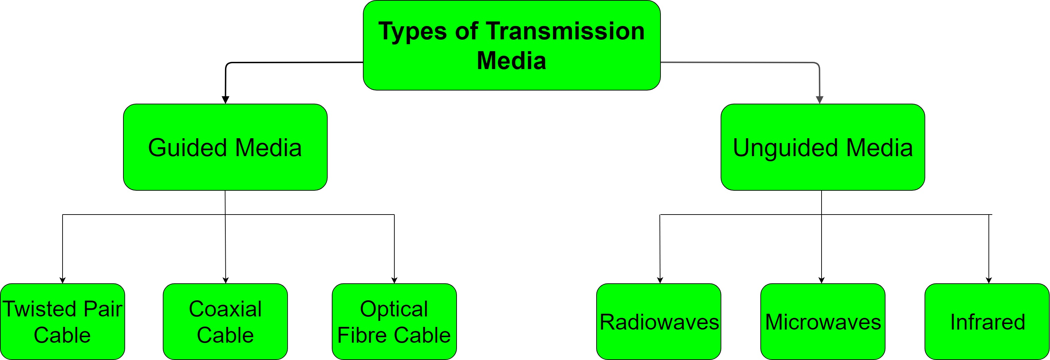

. Twisted Pair Cable
Twisted pair cables have been around for a long time. They were mainly invented for voice transmissions.
Twisted pair is a widely used medium in networking because it's lighter, cheaper, more flexible, easy to install, and provides greater speeds than coaxial cables.
There are two types of twisted pair cables: the unshielded twisted pair (UTP) and the shielded twisted pair (STP). Let's take a closer look at each of them.
The unshielded twisted pair cable has 4 pairs of copper wires that are present inside a plastic sheath. These wires are twisted to protect them from interference. The only protection available for a UTP cable is a plastic sheath that is thin in size.

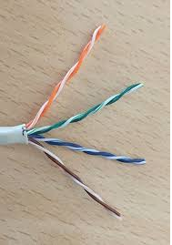
Unshielded Twisted Pair Cable

The shielded twisted pair cable is widely used in high-speed networks. The major difference between UTP and shielded twisted pair is that STP makes use of a metallic shield to wrap the wires. This metallic shield prevents interference to a better extent than UTP. These STP cables come with numbering; the higher the numbering, the better the interference prevention. As an example: most computer networks must go with CAT 3 or CAT 5, and nothing less than this.

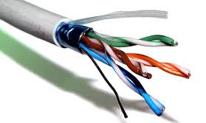
Shielded Twisted Pair Cable

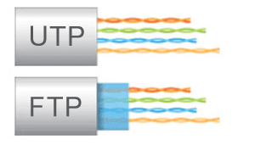
UTP and STP Difference

2. Coaxial Cables
The coaxial cables have a central copper conductor, surrounded by an insulating layer, a conducting shield, and the outermost plastic sheath. Thus, there are three insulation layers for the inner copper cable.
Cable TV and mainly use coaxial cables. Coaxial cables have better resistance to cross talk than twisted pair cables. The coaxial cables are used for long distance communication.
The most widely used types of coaxial cables are RG-59 and RG-6 (RG stands for 'radio guide'). RG-59 has lesser shielding and is suitable for short cable lengths and cable TV connections.

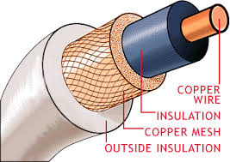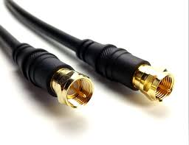
Coaxial Cable

There are many advantages to coaxial cables, including the following:
- High bandwidth
- Easy and cheap installation
- Better immunity from noise
- Better scaling
However, there are also a number of disadvantages to coaxial cables, which include the following:
- They're more prone to lightning strikes.
- They cover less distance than fiber optic cables.
- They carry less bandwidth than both fiber optic and twisted pair cables.
Now let's move onto a different type of guided transmission media.

3. Optical Fibers
Optical fibers use light waves for transmission. Crosstalk, EMI, and attenuation aren't issues with optical fibers. These cables are well-suited for voice, data, and video transmissions.
Optical fibers are the most secure of all the cable media. Installation and maintenance are difficult and costly.
Fiber optic cables have greater transmission speed, high bandwidth, and the signal can travel longer distances when compared to coaxial and twisted pair cables.
Though the cost of optical fiber cable is less compared to co-axial and twisted pair cables, the additional optical components needed for installation make fiber optic the costliest of all the cables.

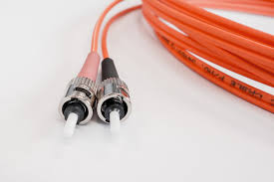
Optical Fiber Cable

Serial and Parallel Communication
Definition of Serial Communication
In serial communication the data bits are transmitted serially over a common communication link one after the other.
Basically it does not allow simultaneous transmission of data because only a single channel is utilized. Thereby allowing sequential transfer rather than simultaneous transfer.

The figure below shows the serial data transmission:
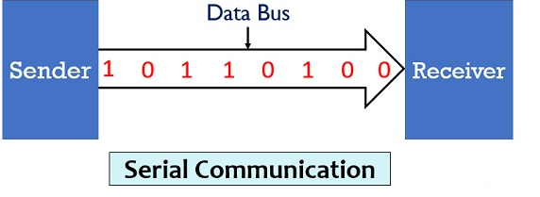

It is highly suitable for long distance signal transmission as only a single wire or bus is used. So, it can be connected between two points that are separated at a large distance with respect to each other.
But as only a single data bit is transmitted per clock pulse thus the transmission of data is a quiet time taking process.

Definition of Parallel Communication
In parallel communication the various data bits are simultaneously transmitted using multiple communication links between sender and receiver.

Here, despite using a single channel between sender and receiver, various links are used and each bit of data is transmitted separately over all the communication link.

The figure below shows the transmission of 8 byte data using parallel communication technique:parallel communication
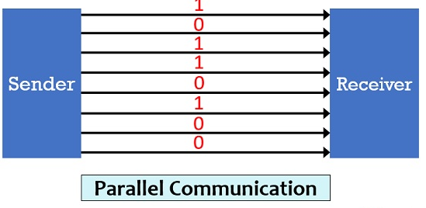
Here, as we can see that for the transmission of 8-bit of data, 8 separate communication links are utilized. And so rather following a sequential data transmission, simultaneous transmission of data is allowed.
This leads to a faster communication between the sender and receiver. But for connecting multiple lines between sender and receiver multiple connecting unit are to be present between a pair of sender and receiver.
And this is the reason why parallel communication is not suitable for long distance transmission, because connecting multiple lines to large distances is very difficult and expensive.

Modulation & Demodulation
The frequency of a Radio frequency channel can be explained best as the frequency of a carrier wave. A carrier wave is purely made up of constant frequency, bit similar to sine wave. It doesn’t carry much information that we can relate to data or speech. The concepts of Amplitude Modulation, Modulation and Demodulation, along with their difference is explained below.
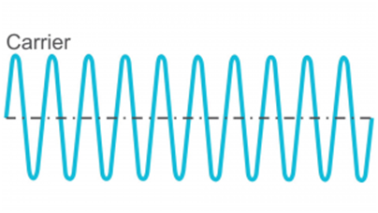
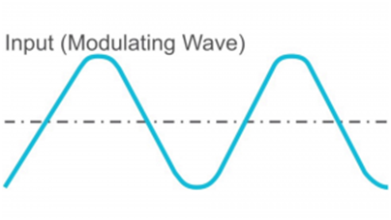

To involve data information or speech information, another wave has to be imposed known as input signal above the carrier wave. This process of imposing an input signal on a carrier wave is known as modulation. Put differently; modulation modifies the shape of a carrier wave to encode the data information that we intended in carrying. Modulation is similar to hiding a code in the carrier wave.

Types of Modulation
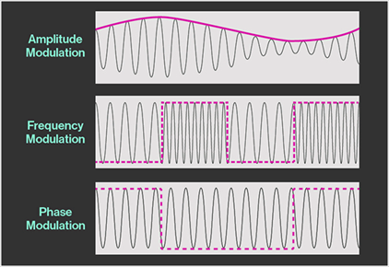
There are three types of modulation namely:
- Frequency modulation
- Amplitude modulation
- Phase modulation.

Amplitude modulation
A kind of modulation where the amplitude of the carrier signal is changed in proportion to the message signal while the phase and frequency are kept constant.

Phase modulation
A kind of modulation where the phase of the carrier signal is altered according to the low frequency of the message signal is called as phase modulation.

Frequency modulation
A kind of modulation where the frequency of the carrier signal is altered in proportion to the message signal while the phase and amplitude are kept constant.

What is Demodulation?
Demodulation is defined as extracting the original information carrying signal from a modulated carrier wave. A demodulator is an electronic circuit that is mainly used to recover the information content from the modulated carrier wave. The output signal via demodulator may describe the sound, images or binary data.
The word "modem" is a contraction of the words modulator-demodulator. A modem is typically used to send digital data over a phone line.
The sending modem modulates the data into a signal that is compatible with the phone line, and the receiving modem demodulates the signal back into digital data. Wireless modems convert digital data into radio signals and back.
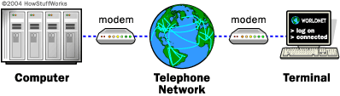
The word "modem" is a contraction of the words modulator-demodulator. A modem is typically used to send digital data over a phone line.
The sending modem modulates the data into a signal that is compatible with the phone line, and the receiving modem demodulates the signal back into digital data. Wireless modems convert digital data into radio signals and back.
A computer network is a group of computers connected with each other through a transmission medium such as cable, wire etc. In this guide, we will discuss the types of computer networks in detail.

Types of Computer Network
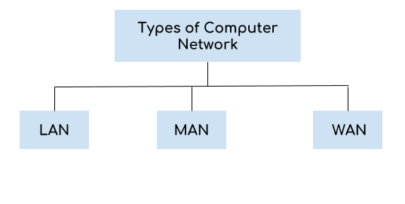
There are mainly three types of computer networks based on their size:
1. Local Area Network (LAN)
2. Metropolitan Area Network (MAN)
3. Wide area network (WAN)

1. Local Area Network (LAN)
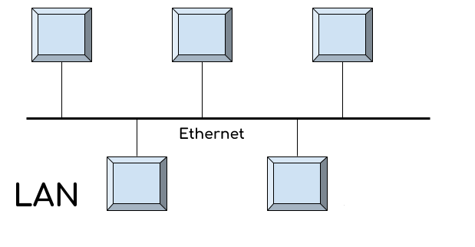
1. Local area network is a group of computers connected with each other in a small places such as school, hospital, apartment etc.
2. LAN is secure because there is no outside connection with the local area network thus the data which is shared is safe on the local area network and can’t be accessed outside.
3. LAN due to their small size are considerably faster, their speed can range anywhere from 100 to 100Mbps.
4. LANs are not limited to wire connection, there is a new evolution to the LANs that allows local area network to work on a wireless connection.

2. Metropolitan Area Network (MAN)
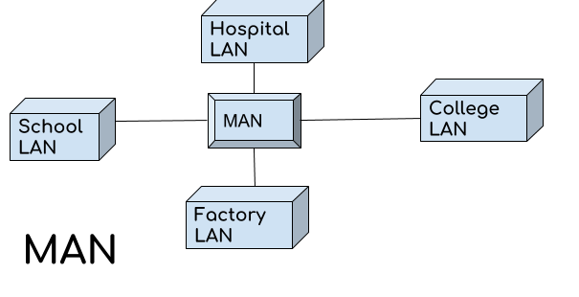
MAN network covers larger area by connections LANs to a larger network of computers. In Metropolitan area network various Local area networks are connected with each other through telephone lines. The size of the Metropolitan area network is larger than LANs and smaller than WANs(wide area networks), a MANs covers the larger area of a city or town.

3. Wide area network (WAN)
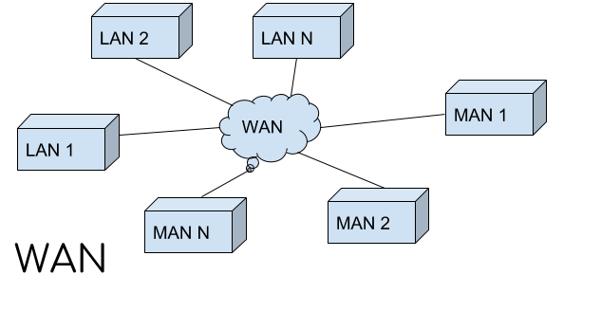
Wide area network provides long distance transmission of data. The size of the WAN is larger than LAN and MAN. A WAN can cover country, continent or even a whole world. Internet connection is an example of WAN.

Types of Network Topology
Network Topology is the schematic description of a network arrangement, connecting various nodes(sender and receiver) through lines of connection.

BUS Topology
Bus topology is a network type in which every computer and network device is connected to single cable. When it has exactly two endpoints, then it is called Linear Bus topology.

Bus topology in computer networks
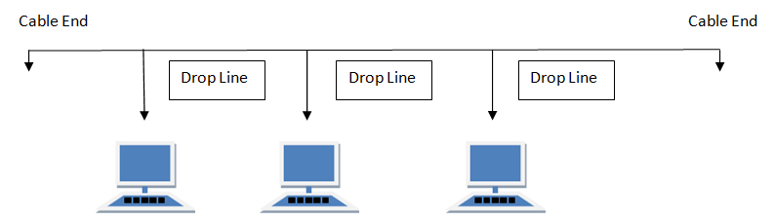
Features of Bus Topology
- It transmits data only in one direction.
- Every device is connected to a single cable
Advantages of Bus Topology
- It is cost effective.
- Cable required is least compared to other network topology.
- Used in small networks.
- It is easy to understand.
- Easy to expand joining two cables together.
Disadvantages of Bus Topology
- Cables fails then whole network fails.
- If network traffic is heavy or nodes are more the performance of the network decreases.
- Cable has a limited length.
- It is slower than the ring topology.
RING Topology
It is called ring topology because it forms a ring as each computer is connected to another computer, with the last one connected to the first. Exactly two neighbours for each device.
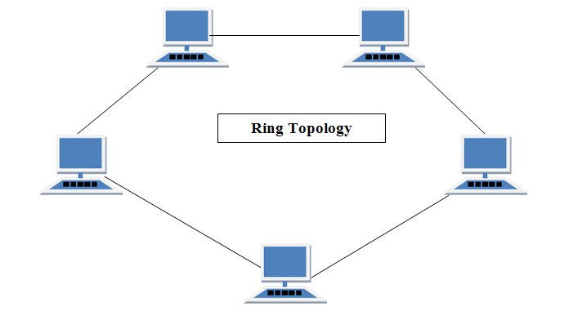
Ring topology in computer networks
Features of Ring Topology
A number of repeaters are used for Ring topology with large number of nodes, because if someone wants to send some data to the last node in the ring topology with 100 nodes, then the data will have to pass through 99 nodes to reach the 100th node. Hence to prevent data loss repeaters are used in the network.
The transmission is unidirectional, but it can be made bidirectional by having 2 connections between each Network Node, it is called Dual Ring Topology.
In Dual Ring Topology, two ring networks are formed, and data flow is in opposite direction in them. Also, if one ring fails, the second ring can act as a backup, to keep the network up.
Data is transferred in a sequential manner that is bit by bit. Data transmitted, has to pass through each node of the network, till the destination node.
Advantages of Ring Topology
- Transmitting network is not affected by high traffic or by adding more nodes, as only the nodes having tokens can transmit data.
- Cheap to install and expand
Disadvantages of Ring Topology
- Troubleshooting is difficult in ring topology.
- Adding or deleting the computers disturbs the network activity.
- Failure of one computer disturbs the whole network.
STAR Topology
In this type of topology all the computers are connected to a single hub through a cable. This hub is the central node and all others nodes are connected to the central node.
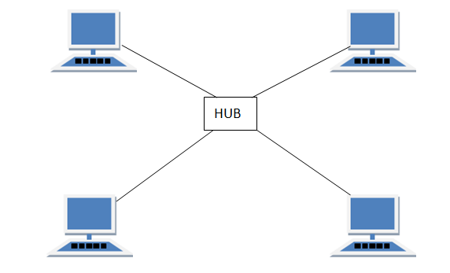
Star topology in computer networks

Features of Star Topology
- Every node has its own dedicated connection to the hub.
- Hub acts as a repeater for data flow.
- Can be used with twisted pair, Optical Fibre or coaxial cable.
Advantages of Star Topology
- Fast performance with few nodes and low network traffic.
- Hub can be upgraded easily.
- Easy to troubleshoot.
- Easy to setup and modify.
- Only that node is affected which has failed, rest of the nodes can work smoothly.
Disadvantages of Star Topology
- Cost of installation is high.
- Expensive to use.
- If the hub fails then the whole network is stopped because all the nodes depend on the hub.
- Performance is based on the hub that is it depends on its capacity
MESH Topology
It is a point-to-point connection to other nodes or devices. All the network nodes are connected to each other. There are two techniques to transmit data over the Mesh topology, they are :
Routing
Flooding
MESH Topology: Routing
In routing, the nodes have a routing logic, as per the network requirements. Like routing logic to direct the data to reach the destination using the shortest distance. Or, routing logic which has information about the broken links, and it avoids those node etc. We can even have routing logic, to re-configure the failed nodes.

MESH Topology: Flooding
In flooding, the same data is transmitted to all the network nodes, hence no routing logic is required. The network is robust, and the its very unlikely to lose the data. But it leads to unwanted load over the network.
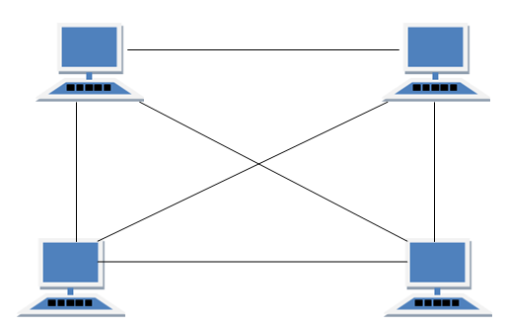
Mesh topology in computer networks
Features of Mesh Topology
- Fully connected.
- Robust.
- Not flexible.
Advantages of Mesh Topology
- Each connection can carry its own data load.
- It is robust.
- Fault is diagnosed easily.
- Provides security and privacy.
Disadvantages of Mesh Topology
- Installation and configuration is difficult.
- Cabling cost is more.
- Bulk wiring is required.
TREE Topology
It has a root node and all other nodes are connected to it forming a hierarchy. It is also called hierarchical topology. It should at least have three levels to the hierarchy.
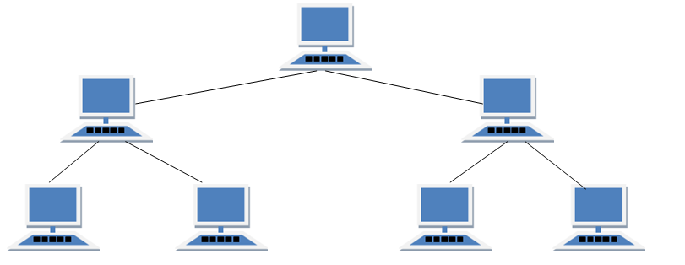
Tree topology in computer networks

Features of Tree Topology
- Ideal if workstations are located in groups.
- Used in Wide Area Network.
Advantages of Tree Topology
- Extension of bus and star topologies.
- Expansion of nodes is possible and easy.
- Easily managed and maintained.
- Error detection is easily done.
Disadvantages of Tree Topology
- Heavily cabled.
- Costly.
- If more nodes are added maintenance is difficult.
- Central hub fails, network fails.
HYBRID Topology
It is two different types of topologies which is a mixture of two or more topologies. For example if in an office in one department ring topology is used and in another star topology is used, connecting these topologies will result in Hybrid Topology (ring topology and star topology).

Hybrid topology in computer networks
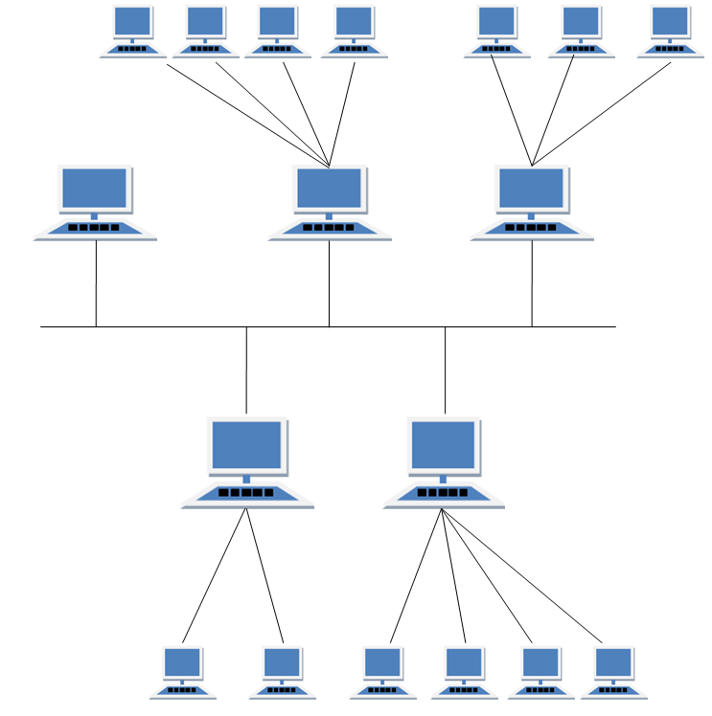
Features of Hybrid Topology
- It is a combination of two or topologies
- Inherits the advantages and disadvantages of the topologies included
Advantages of Hybrid Topology
- Reliable as Error detecting and trouble shooting is easy.
- Effective.
- Scalable as size can be increased easily.
- Flexible.
Disadvantages of Hybrid Topology
- Complex in design.
- Costly.

Dialup Internet Service
This is the most common basic type of connection available from ISPs (Internet Service Provider).In Dial-up connection, we use our computer, dial a phone number (provider by ISP) to get connected to server at Providers end through which we access Internet.It means we are not directly connected to Internet; we access the Internet through an Internet Service Provider.
Dialup internet service is a service that allows connectivity to the internet through a standard telephone line. By connecting the telephone line to the modem in your computer and inserting the other end into the phone jack, and configuring the computer to dial a specific number provided by your internet service provider (ISP) you are able to access the internet on your computer.
Dial up internet service is provided through several ISP. The majority of internet service providers give you a set of telephone numbers either national or local that allows you to dial into a network that feeds into the internet. This allows you to receive and send email, search the World Wide Web, participate in chat rooms and plenty of other features the web has to offer.
In order to get a dial up internet service a person must definitely have a computer and even more important a modem. There are different types of modems, and most of them are inexpensive to purchase. You can have an internal modem installed in a free slot of your computer, or you can have an external modem that's hooked up to the computer through cables. A telephone line is linked to the modem.
The modem whether external or internal is controlled by software on the computer. With Microsoft Windows operating system that software is the Network Connection utility which allows you to connect to the internet. How? In the Network Connection utility you have to set up ISP profile so that the modem knows what phone number to dial so that you can connect to the internet.
Broadband
Broadband is the term that pertains generally to an internet service that often runs on cable connection, but is also available as DSL, or Fiber. Messaging and communication has never been as easy or as convenient as it is now. All this is thanks to the invention of the internet, and a huge part of this success is attributed to the development of broadband technology. Broadband was first used in the early 2000s. It provided internet users with the opportunity to browse and use the internet while making a phone call. It did this by splitting the signal transmission between internet data and telephone data

Leased Lines
A leased line is a private bidirectional or symmetric telecommunications circuit between two or more locations provided according to a commercial contract. It is sometimes also known as a private circuit.
Unlike traditional telephone lines in the public switched telephone network (PSTN) leased lines are generally not switched circuits, and therefore do not have an associated telephone number. Each side of the line is permanently connected and dedicated to the other. Leased lines can be used for telephone, Internet, or other data communication services.
Typically, leased lines are used by businesses to connect geographically distant offices. Unlike dial-up connections, a leased line is always active. The primary factors affecting the recurring lease fees are distance between end points and the bandwidth of the circuit. Since the connection does not carry third-party communications, the carrier can assure a given level of quality.
An Internet leased line is a premium Internet connectivity product, normally delivered over fiber, which provides uncontended, symmetrical bandwidth with full duplex traffic. It is also known as an Ethernet leased line, dedicated line, data circuit or private line.
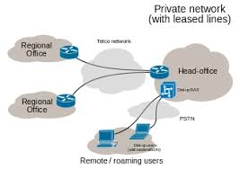
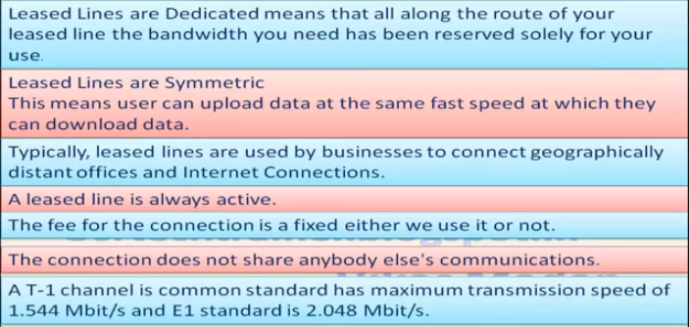
ISDN
The Integrated Services of Digital Networking, in short ISDN is a telephone network based infrastructure that allows the transmission of voice and data simultaneously at a high speed with greater efficiency. This is a circuit switched telephone network system, which also provides access to Packet switched networks.
Integrated Services Digital Network (ISDN) is a set of communication standards for simultaneous digital transmission of voice, video, data, and other network services over the traditional circuits of the public switched telephone network. It was first defined in 1988 in the CCITT .
Integrated Services Digital Network (ISDN) is a set of communication standards for simultaneous digital transmission of voice, video, data, and other network services over the traditional circuits of the public switched telephone network. It was first defined prior to ISDN, the telephone system was viewed as a way to transport voice, with some special services available for data. The key feature of ISDN is that it integrates speech and data on the same lines, adding features that were not available in the classic telephone system. The ISDN standards define several kinds of access interfaces, such as Basic Rate Interface (BRI), Primary Rate Interface (PRI), Narrowband ISDN (N-ISDN), and Broadband ISDN (B-ISDN).

ISDN is a circuit-switched telephone network system, which also provides access to packet switched networks, designed to allow digital transmission of voice and data over ordinary telephone copper wires, resulting in potentially better voice quality than an analog phone can provide. It offers circuit-switched connections (for either voice or data), and packet-switched connections (for data), in increments of 64 kilobit/s.
Electromagnetic Waves
These are waves that consist of vibrating electric and magnetic fields. They transmit energy through matter or across space. Some electromagnetic waves are generally harmless.Like other waves, electromagnetic waves have properties of speed, wavelength, and frequency. Radio waves, microwaves, visible light, and x rays are all examples of electromagnetic waves that differ from each other in wavelength.
Radio frequency (RF)
Radio frequency (RF) is a measurement representing the oscillation rate of electromagnetic radiation spectrum, or electromagnetic radio waves, from frequencies ranging from 300 GHz to as low as 9 kHz. With the use of antennas and transmitters, an RF field can be used for various types of wireless broadcasting and communications.

How radio frequency works
Radio frequency is measured in units called hertz, which represent the number of cycles per second when a radio wave is transmitted. One hertz equals one cycle per second; radio waves range from thousands (kilohertz) to millions (megahertz) to billions (gigahertz) of cycles per second. Microwaves are a type of radio wave with higher frequencies. Radio frequencies are not visible to the human eye.
RF technology
Many types of wireless devices make use of RF fields. Cordless and cellphones, radio and television broadcast stations, Wi-Fi and Bluetooth, satellite communications systems, and two-way radios all operate in the RF spectrum. Some wireless devices, like TV remote controls, some cordless computer keyboards and computer mice, operate at IR frequencies, which have shorter electromagnetic wavelengths.
DSL

Stands for "Digital Subscriber Line." DSL is a communications medium used to transfer digital signals over standard telephone lines. Along with cable Internet, DSL is one of the most popular ways ISPs provide broadband Internet access.
When you make a telephone call using a landline, the voice signal is transmitted using low frequencies from 0 Hz to 4 kHz. This range, called the "voiceband," only uses a small part of the frequency range supported by copper phone lines. Therefore, DSL makes use of the higher frequencies to transmit digital signals, in the range of 25 kHz to 1.5 MHz. While these frequencies are higher than the highest audible frequency (20 kHz), then can still cause interference during phone conversations. Therefore, DSL filters or splitters are used to make sure the high frequencies do not interfere with phone calls.
In order to access the Internet using DSL, you must connect to a DSL Internet service provider (ISP). The ISP will provide you with a DSL modem.
INTERNET
The Internet is a global network of billions of computers and other electronic devices. With the Internet, it's possible to access almost any information, communicate with anyone else in the world, and do much more.
It's important to realize that the Internet is a global network of physical cables, which can include copper telephone wires, TV cables, and fiber optic cables. Even wireless connections like Wi-Fi and 3G/4G rely on these physical cables to access the Internet.
When you visit a website, your computer sends a request over these wires to a server. A server is where websites are stored, and it works a lot like your computer's hard drive. Once the request arrives, the server retrieves the website and sends the correct data back to your computer.
One of the best features of the Internet is the ability to communicate almost instantly with anyone in the world. Email is one of the oldest and most universal ways to communicate and share information on the Internet, and billions of people use it. Social media allows people to connect in a variety of ways and build communities online.

VPN or Virtual Private Network
A Virtual Private Network is a connection method used to add security and privacy to private and public networks, like WiFi Hotspots and the Internet. Virtual Private Networks are most often used by corporations to protect sensitive data. However, using a personal VPN is increasingly becoming more popular as more interactions that were previously face-to-face transition to the Internet. Privacy is increased with a Virtual Private Network because the user's initial IP address is replaced with one from the Virtual Private Network provider. Subscribers can obtain an IP address from any gateway city the VPN service provides.

Why do I need a VPN?
- Hide your IP address
Connecting to a Virtual Private Network often conceals your real IP address.
- Change your IP address
Using a VPN will almost certainly result in getting a different IP address.
- Encrypt data transfers
A Virtual Private Network will protect the data you transfer over public WiFi.
- Mask your location
With a Virtual Private Network, users can choose the country of origin for their Internet
connection.
- Access blocked websites
Get around website blocked by governments with a VPN.
Components of LAN – Media, NIC, NOS, Bridges, Adaptors, HUB, Routers, Repeater and Gateways.
A network interface card (NIC) is a hardware component without which a computer cannot be connected over a network. It is a circuit board installed in a computer that provides a dedicated network connection to the computer. It is also called network interface controller, network adapter or LAN adapter.

Purpose
- NIC allows both wired and wireless communications.
- NIC allows communications between computers connected via local area network (LAN) as well as communications over large-scale network through Internet Protocol (IP).
- NIC is both a physical layer and a data link layer device, i.e. it provides the necessary hardware circuitry so that the physical layer processes and some data link layer processes can run on it.

Types of NIC Cards
NIC cards are of two types −
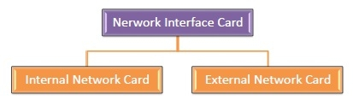

Internal Network Cards
In internal networks cards, motherboard has a slot for the network card where it can be inserted. It requires network cables to provide network access. Internal network cards are of two types. The first type uses Peripheral Component Interconnect (PCI) connection, while the second type uses Industry Standard Architecture (ISA).
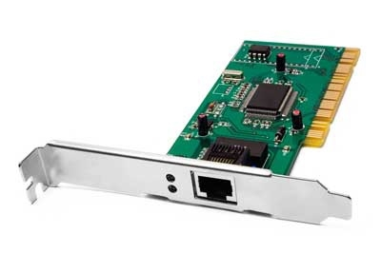

External Network Cards
In desktops and laptops that do not have an internal NIC, external NICs are used. External network cards are of two types: Wireless and USB based. Wireless network card needs to be inserted into the motherboard, however no network cable is required to connect to the network. They are useful while traveling or accessing a wireless signal.
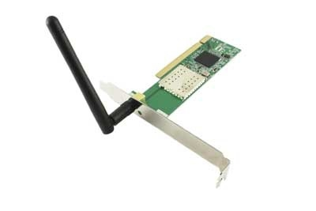
NOS(Network operating systems)

Unlike operating systems, such as Windows, that are designed for single users to control one computer, network operating systems (NOS) coordinate the activities of multiple computers across a network. The network operating system acts as a director to keep the network running smoothly.
Some examples of network operating systems include Microsoft Windows Server 2003, Microsoft Windows Server 2008, UNIX, Linux, Mac OS X, Novell NetWare, and BSD.
The salient features of network operating systems are: Basic operating system features support like protocol support, processor support, hardware detection and multiprocessing support for applications. Security features like authentication, restrictions, authorizations and access control.

Hub

A hub works in the physical layer of the OSI model. It is basically a non-intelligent device, and has no decision making capability. What a Hub basically does is take the input data from one of the ports and broadcast the information to all the other ports connected to the network.
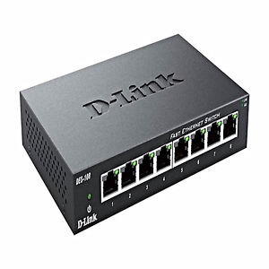
HUB
A
C
B

D

To demonstrate its working, consider a 4 port network as shown in Fig 1. There are 4 computers connected to the 4 ports. Suppose, if Computer A wants to send some data to Computer B using a Hub, then, Computer A broadcasts the data on the network, and Computer B, being connected to the network, has access to the data. But, in this case all the other ports connected to the network has access to the data that is being transmitted by Computer A. This happens because, the Hub works in the Physical Layer and hence it does not know about the MAC addresses of the ports connected to the network. So, there is a lack of security in the Hub.
Repeater

A repeater is a device similar to the Hub, but has additional features. It also works in the Physical layer. The repeaters are used in places where amplification of input signal is necessary. But, the kind of amplification done by the repeater is different from the regular amplification by amplifiers. The regular amplifies everything fed into it. That means, if the input signal has noise induced into it, both the desired signal and noise signal are together amplified. But, in the case of a repeater, it regenerates the input signal, and amplifies only the desirable signal. Hence, the noise component of the signal is eliminated.
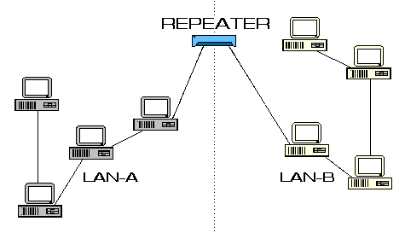
The repeaters are necessary since, during the transmission of the signals over long distances, the signal has attenuation, delay distortions and noise, which lead in loss of data. Hence, in order to prevent this, the regenerative repeaters are used. Hence, the repeater regenerates the faded signal. In addition, it has all the features of a Hub. One common problem between the repeaters and the Hubs are that only one transmission can take place on the network at a particular time. If multiple devices transmit data simultaneously, there will be data collision.

Bridge:

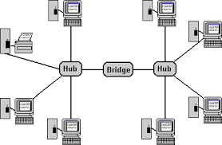
A bridge is also a device which works in the Data Link Layer, but is more primitive when compared to a switch. Initial bridges were used to connect only 2 LAN’s, but the most recent ones perform similar operation as the switches. It also works on the principle of transfer of information using the MAC addresses of the ports.

It can be noted is that the normal ADSL modem can be connected via bridging also. The only difference is that, when bridging is used, each time the device has to be connected to the internet, it has to dial to the internet and establish a connection. Also, a bridge alone cannot be used to connect to the internet, because, the bridge works in the Data Link Layer, and has no knowledge of the IP Addresses, which are used in the Internet.
Bridges are similar to repeaters and hubs in that they broadcast data to every node. However, bridges maintain the media access control (MAC) address table as soon as they discover new segments, so subsequent transmissions are sent to only to the desired recipient.
Gateway

The Gateway devices work in the Transport layer and above, where the different network technologies are implemented. A gateway is necessary when there are different technologies implemented by the different LAN’s which are to be connected together.
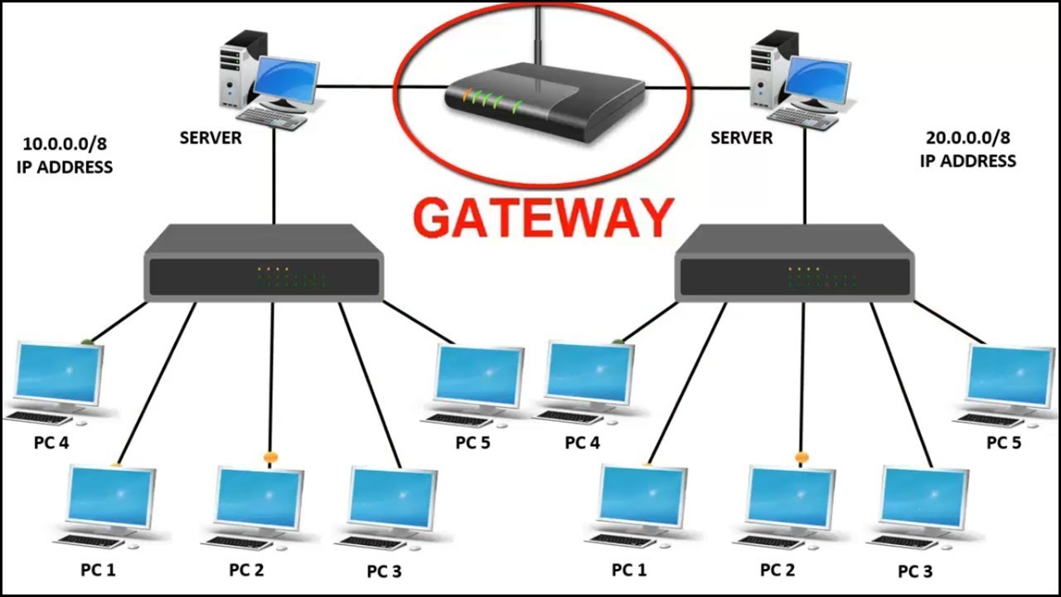

Consider 2 networks, say in New York, and a network in London. If data has to be sent from one place to another, we need to ensure that the network technologies that are being used by both the networks are the same. If not, we need to use a Gateway.

In the more common example, we use a telephone network and internet networks, which works on different technologies. The telephone network follows the ISDN, and the Internet follows the IP. Here, 2 different technologies are being used. In this case, the router fails to work, since the router cannot understand the functionalities of both the networks. Hence, we require a Gateway, which acts as a translator in communicating between the 2 networks.

